Title of the book: Elementary Economics for Hong Kong 2 (5th Edition)
ISBN: 902-397-792-1
Subject: Errata
Last updated on 11 August 2004
Page no. | Original version |  |  |  |  |  |  |  |  |  |  | Revised version
2, 3, 4 | “China” |  |  |  |  |  |  |  |  |  |  | “the mainland” or “The mainland”
2 | Table 1.1 “Historical Events”, row 2 (1842-1950), 2nd point, line 2:  ．…Chinese refugees moved… |  |  |  |  |  |  |  |  |  |  | ．… Refugees from the mainland moved…
2 | Table 1.1 “Historical Events”, row 3 (1951–1965), 1st point  ．Immigrants…Chinese industrialists, brought… |  |  |  |  |  |  |  |  |  |  | ．New arrivals from the mainland, especially the industrialists, brought…
3 | Table 1.1 “Historical Events”, row 1 (1976–1985), 1st point:  ‧There were rapid … |  |  |  |  |  |  |  |  |  |  | ‧There was rapid …
3 | Table 1.1 “Historical Events”, row 1 (1976–1985), 2nd point:  ‧…followed by China’s opening up to the world market and its modernization. |  |  |  |  |  |  |  |  |  |  | ‧…followed by her opening up to the world market and modernization.
3, 4 | “the Mainland” ＝＞ “China’s”  “the mainland” ＝＞ “the mainland’s” or “The mainland’s”
4 | Table 1.1  Add the 6th point at the end of the 3rd column “Major Economic Activities” |  |  |  |  |  | As from 1st January 2004, the mainland and Hong Kong Closer Economic Partnership Arrangement (CEPA) has been fully implemented. Goods of Hong Kong origin will enjoy zero tariff status when exported to the mainland.
8 | Point C, line 3, line 5 and Fig. 2.4  “final goods and services” / “Final Goods & Services” |  |  |  |  |  |  |  |  |  |  | “goods and services” / “Goods & Services”
9 | 1st para., line 1: “… the amount of final” |  |  |  |  |  |  |  |  |  |  | Delete “final”
9 | 1st para.,  “National Output = Total Market Value of all Final Goods and Services |  |  |  |  |  |  |  |  |  |  | Delete “final”.
9 | 2nd para., line 2: “final goods and services” |  |  |  |  |  |  |  |  |  |  | Delete “final”.
9 | 4th para., line 2 and line 4: “final goods” |  |  |  |  |  |  |  |  |  |  | Delete “final”
9 | 4th para., line 4 “the market value of…” |  |  |  |  |  |  |  |  |  |  | “the total value of…”
11-13 | The contents under “Items Excluded from GDP Calculation ”, Closer Look 2.2 ＆ Q.2.1 on p. 13 are put to the middle of Section 2.4 and Q.2.3 on p. 23.
11 | Point 1 Second-hand Goods, line 2: “middle men” |  |  |  |  |  |  |  |  |  |  | “middlemen”
11 | HKCEE Q. 2 → HKCEE Q. 5
12 | 1st para., the last line: “therefore extremely…in GDP.” |  |  |  |  |  |  |  |  |  |  | “extremely…in GDP. Therefore, it is excluded.”
12 | Fig. 2.6 → Fig. 2.14; Fig. 2.7 → Fig. 2.15
12 | Footnote no. 13: double counting 重複計算 → no. 29: transfer of ownership 擁有權的轉讓
12 | Footnote no. 14 → no. 30
13 | Closer Look 2.2 → Closer Look 2.5; Q.2.1 → Q.2.3
13 | Fig. 2.8 → Fig. 2.16
13 | Footnote nos. 15 – 18 → Footnote nos. 31 -- 34
14 | Fig. 2.9 → Fig. 2.6
14 | Revised point A.1. Private Consumption Expenditure (C)  “It is the total value of final consumption expenditure on goods and services by households and private non-profit institutions serving households.  Example:  The expenditure of a family on movies.
14 | Footnote nos. 19 – 24 → Footnote nos. 13 -- 18
15 | HKCEE Q. 3 → HKCEE Q. 2
15 | Closer Look 2. 3 → Closer Look 2.2
15 | Fig. 2.10 (a) → Fig. 2.7 (a)
15 | Footnote nos. 25 – 26 → Footnote nos. 19 - 20
16 | Fig. 2.10 (b) → Fig. 2.7 (b)
17 | Fig. 2.11 → Fig. 2.8; Q.2. 2 → Q.2. 1
17 | Fig. 2.11 the nametag “from China” |  |  |  |  |  |  |  |  |  |  | “from the mainland”
17 | Point B. line 1 to line 2 “…measures the total market value of all final goods and services…” |  |  |  |  |  |  |  |  |  |  | “…measures the total value of all goods and services…”
17 | Footnote nos. 27 – 28 → Footnote nos. 21 -- 22
18 | 1st para. “In computing GDP…double counting.” And  the note on the margin:  “Double counting…repeatedly.” |  |  |  |  |  |  |  |  |  |  | Delete these 2 parts.
18 | 2nd para., “Let us… in Fig. 2.12.” |  |  |  |  |  |  |  |  |  |  | “Let us…in Fig. 2.9.”
18 | Fig. 2.12 → Fig. 2.9; HKCEE Q. 4 → HKCEE Q. 3
18 | 3rd para. “Only the market…double counting occurs.” |  |  |  |  |  |  |  |  |  |  | Delete this para.
18 | 4th para., line 1: “To avoid double counting in measuring GDP, the value added” |  |  |  |  |  |  |  |  |  |  | “In measuring GDP, the value added”
18 | Footnote no. 29 → Footnote no. 23
19 | 1st para., line 2 “…in Fig. 2.12.” |  |  |  |  |  |  |  |  |  |  | “…in Fig. 2.9”
19 | 2nd para., line 1: “It is equal to the market value of the final good(i.e., bread).” |  |  |  |  |  |  |  |  |  |  | “It is equal to the value of the bread.”
19 | Fig. 2.13 → Fig. 2.10
19 | Footnote no. 30 → Footnote no. 24
20 | Fig. 2.14 → Fig. 2.11
20 | Footnote no. 31 → Footnote no. 25
21 | 1st para, line 1 “We use Closer Look 2.4 to…” |  |  |  |  |  |  |  |  |  |  | “We use Closer Look 2.3 to…”
21 | Closer Look 2.4 → Closer Look 2.3
21 | Fig. 2.15 → Fig. 2.12
21 | Closer Look 2.4, point (b), revised as follows  (b) Since the value of output should be equal to the total returns to the inputs used in production, that is  Value of Output = Returns to Inputs  B = A + C + D  ＝＞ B – A = C + D
21 | Footnote nos. 32 – 33 → Footnote nos. 26 – 27
22 | 2nd para., line 4 “Factor income includes” |  |  |  |  |  |  |  |  |  |  | “Factor incomes include”
22 | Note: (1), line 1:  “Factor income only includes income…” |  |  |  |  |  |  |  |  |  |  | “Factor incomes only include incomes…”
22 | Closer Look 2. 5 → Closer Look 2. 4
22 | Closer Look 2. 5, line 1 : “From Closer Look 2. 4…” |  |  |  |  |  |  |  |  |  |  | “From Closer Look 2. 3…”
22 | (Closer Look 2. 5 about the income …syllabus.) |  |  |  |  |  |  |  |  |  |  | (Closer Look 2. 4 about the income …syllabus.)
22 | Footnote no. 34 → Footnote no. 28
23 | Fig. 2.16 → Fig. 2. 13; Q.2.3 → Q.2.2
25 | “China” |  |  |  |  |  |  |  |  |  |  | “the mainland”
25 | Closer Look 2. 7, point (1), 2nd para., line 1:  “The final goods produced…” |  |  |  |  |  |  |  |  |  |  | Delete “final”.
26 | 2nd para., line 5 to line 6: “Net factor income from abroad measures such difference.” |  |  |  |  |  |  |  |  |  |  | Delete this sentence.
26 | The 3rd text box  Net External Factor Income Flows  = Factor Income earned…- Factor Income earned… |  |  |  |  |  |  |  |  |  |  | Net External Factor Income Flows  = Factor Incomes earned…- Factor Incomes earned…
27 | (Closer Look 2.8…for furthe study….) |  |  |  |  |  |  |  |  |  |  | (Closer Look 2.8…for further study….)
28 | 1st para., line 1: “…the gross income net from…” |  |  |  |  |  |  |  |  |  |  | “…the GDP net from…”
28 | Point B, line 1 to line 2:  “Per capita GDP measures the average or per head income of a country.” |  |  |  |  |  |  |  |  |  |  | “Per capita GDP measures the average or per head income arising from current production of an economy.”
28 | Point C line 3 “… value of final goods…” |  |  |  |  |  |  |  |  |  |  | “… value of goods…”
29 | “final goods and services” |  |  |  |  |  |  |  |  |  |  | Delete “final”.
29 | Add the heading of “D. Implicit Price Deflator of GDP” on top of the last para.(In real world …).
30 | 4th para., line 2 to line 3 “implicit GDP deflator” |  |  |  |  |  |  |  |  |  |  | Delete “implicit”.
30 | 5th para. “To find the implicit GDP deflator” |  |  |  |  |  |  |  |  |  |  | Delete “implicit”.
30 | The text box “Implicit GDP Deflator = ….” |  |  |  |  |  |  |  |  |  |  | “Implicit Price Deflator of GDP = …”
30 | Closer Look 2.10, 2nd para., line 1 and line 2  “implicit GDP deflator” |  |  |  |  |  |  |  |  |  |  | Delete “implicit”.
30 | 3rd para. “The ratio between…the price indices.” ＆  the formula: Price Index of the Base Year = Real GDP  Price Index of the Current Year Money GDP  ＆ the note on the margin:  Price Index of the Base Year = Real GDP  Price Index of the Current Year Money GDP |  |  |  |  |  |  |  |  |  |  | Delete these 3 parts.
31 | The 1st text box “Implicit GDP Deflator = …” |  |  |  |  |  |  |  |  |  |  | “Implicit Price Deflator of GDP = …”
31 | Q2.5 (b), line 2: “implicit price deflator GDP” |  |  |  |  |  |  |  |  |  |  | “implicit price deflator of GDP”
35 | Section 2.7 point 1 and Fig. 2.22: “GNP” → “GDP”
36-39 | All “GNP” → “GDP”
38 | Fig. 2.26 “PERSONAL SERVICES” |  |  |  |  |  |  |  |  |  |  | “NON-MARKET PERSONAL SERVICES”
38 | News Online 2.1, 1st para., line 2 “of China”…specialists point out that there are also” |  |  |  |  |  |  |  |  |  |  | “of the mainland …specialists pointed out that there were also”
38 | News Online 2.1, line 5 “include tax evasion…” |  |  |  |  |  |  |  |  |  |  | “included tax evasion…”
39 | “final goods and services” |  |  |  |  |  |  |  |  |  |  | Delete “final”
 | Table 2.7, “Demand-Side Factors”, row 4:  ．Net Exports Demand  Larger net exports mean a larger demand for goods and services by foreigners. This will lead to an increase in GNP. |  |  |  |  |  |  |  |  |  |  | ．Net Exports Demand  Larger net exports mean a larger demand for goods and services by foreigners or a smaller local demand for imports. This will lead to an increase in GDP.
41 | Economics Clinic  3. If both real…GDP will”  A. increase by 10%.  B. increase by less than 10%  C. increase by more than 10%.  D. remain unchanged. |  |  |  |  |  |  |  |  |  |  | 3. If both real…GDP must have”  A. increased by 10%.  B. increased by less than 10%  C. increased by more than 10%.  D. remained unchanged.
41 | 2nd Dr Economics says, last line:  “…GNP would increase by more…” |  |  |  |  |  |  |  |  |  |  | “…GDP must have increased by more…”
43 | Multiple-choice Questions, New Q. 2  2. The standard of living of country X is higher than that of country Y when  A. The GDP of country X is higher than the GDP of country Y.  B. The implicit price deflator of GDP of country X is smaller than that of country Y.  C. The per capita GDP of country X is higher than that of country Y.  D. The population of country Y is higher than that of country X.
Multiple-choice Questions, Revised Q. 3:
3. Mr Stone received the following last year:
(a) A salary of $20 000
(b) $4 000 from horse racing
(c) A bonus of $5 000
His contribution to GDP was
A. $20 000. C. $25 000.
B. $24 000. D. $29 000.
45 | Structured Questions Q 1(b),line 2 “China” |  |  |  |  |  |  |  |  | “the mainland”
45 | Structured Questions Q.3 line 2:  “the owner at the same year.” |  |  |  |  |  |  |  |  | “the owner in the same year.”
45 | Structured Questions Q.4: “GNP figures…” |  |  |  |  |  |  |  |  | “GDP figures…”
47 | Objectives, Point (7):  (7) “Understand how depositing and …” |  |  |  |  |  |  |  |  | (7) “Understand how deposits and …”
47 | Section 3.1, point 1, 1st para., line 2:  “parties in an exchange own the goods…” |  |  |  |  |  |  |  |  | “parties in an exchange want to sell the goods…”
48 | Point 2, line 4:  “…difficult to sell the goat for a” |  |  |  |  |  |  |  |  | “…difficult to sell the goat for half a”
50 | Footnote no. 8: store of value 儲藏價值 |  |  |  |  |  |  |  |  | Footnote no. 8 :store of value 價值儲藏
54 | Closer Look 3.2, point (1), line 3:  “card. Whereas time deposits are…” |  |  |  |  |  |  |  |  | “card. Time deposits are…”
54 | Closer Look 3.2, point (3), line 1:  “Time deposits almost guarantee the …” |  |  |  |  |  |  |  |  | “Time deposits guarantee the …”
54 | Closer Look 3.2, Point (3), line 2:  “…savings deposits. Thus, the…” |  |  |  |  |  |  |  |  | “…savings deposits. Bank interest rates change from time to time. Thus, the…”
56 | Closer Look 3.3, point (4), 1st para. :  “ The use of credit…a month later.” |  |  |  |  |  |  |  |  | “ Credit cards cannot serve as a standard for deferred payment as future payments cannot be expressed in terms of them.”
59 | Section 3.5 A What is Legal Tender? – Definition:  “Legal tender is the money allowed by the government to be acceptable in all cases for payment of goods and services as well as for settlement of debts.” |  |  |  |  |  |  |  |  | “Legal tender is the money that is legally valid for payment of goods and services as well as for settlement of debts and that must be accepted for that purpose when offered.”.
59 | The note on the margin:  “…allowed by the government to be acceptable … settlement of debts.” |  |  |  |  |  |  |  |  | “… legally valid … settlement of debts and that must be accepted for that purpose when offered.”
68 | Economics Clinic, Q 4, Dr Economics says,  Option C, line 1 to line 3:  “However…which is a component of M3.” |  |  |  |  |  |  |  |  | This sentence is deleted.
74 | Point B, Examples:  “Hang Seng Bank Ltd., Dao Heng Bank Ltd.⁸” |  |  |  |  |  |  |  |  | “Hang Seng Bank Ltd., CITIC Ka Wah Bank Ltd.⁸”
74 | Websites on the margin:  Dao Heng Bank  http://www.daoheng.com |  |  |  |  |  |  |  |  | CITIC Ka Wah Bank  http://www.citickawahbank.com
74 | New Fig. 4.2 An example of a commercial bank  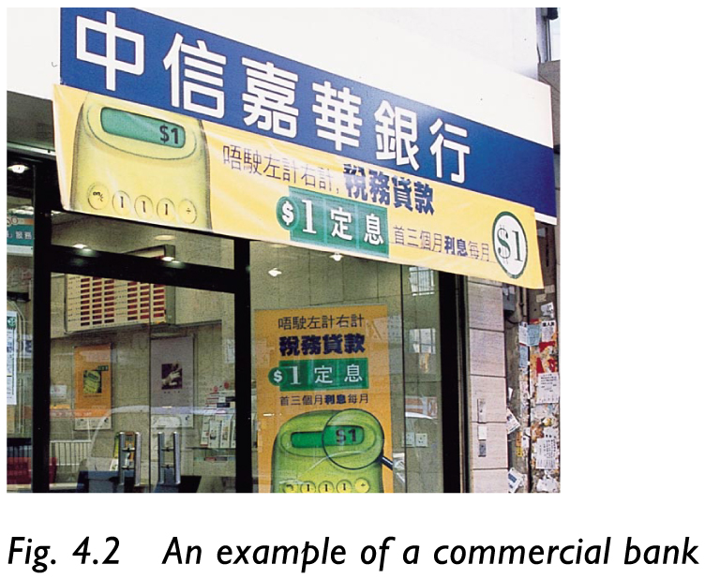
74 | Footnote no. 8:  Dao Heng Bank Ltd. 道亨銀行有限公司 |  |  |  |  |  |  |  |  |  | Footnote no. 8:  CITIC Ka Wah Bank Ltd. 中信嘉華銀行有限公司
75 | Section 4.3, point 2, line 1 to line 2:  “It has the duty to…bank crisis.” |  |  |  |  |  |  |  |  |  | “It serves to maintain the stability of the banking system.”
77 | Add the sentence between Closer Look 4.2 and Section 4.4. |  |  |  |  |  |  |  |  |  | “Closer Look 4.2 about discount rate as a tool of monetary policy is for further study purposes. It is not required in the HKCEE syllabus.”
78 | Examples, 2nd para., line 2:  “Monetary Authority becomes…” |  |  |  |  |  |  |  |  |  | “the Hong Kong Monetary Authority becomes …”
78 | Point 2, 2nd last line  “…issuing coins. The…” |  |  |  |  |  |  |  |  |  | “…issuing coins and the $10 note. The…”
78 | Point 3, line 3:  “… The treasury ²⁶ pays …” |  |  |  |  |  |  |  |  |  | “… The Treasury ²⁶ pays …”
78 | Footnote no. 26  treasury 庫房 |  |  |  |  |  |  |  |  |  | Footnote no. 26  Treasury庫房
80 | News Online 4.1, line 3 ＆ line 4:  “in the Mainland” |  |  |  |  |  |  |  |  |  | “in the mainland”
80 | Dr Economics says, line 1:  “… for big or small accounts are …” |  |  |  |  |  |  |  |  |  | “… for big and small accounts are …”
87 | New Fig. 4.15 Futures market in Hong Kong  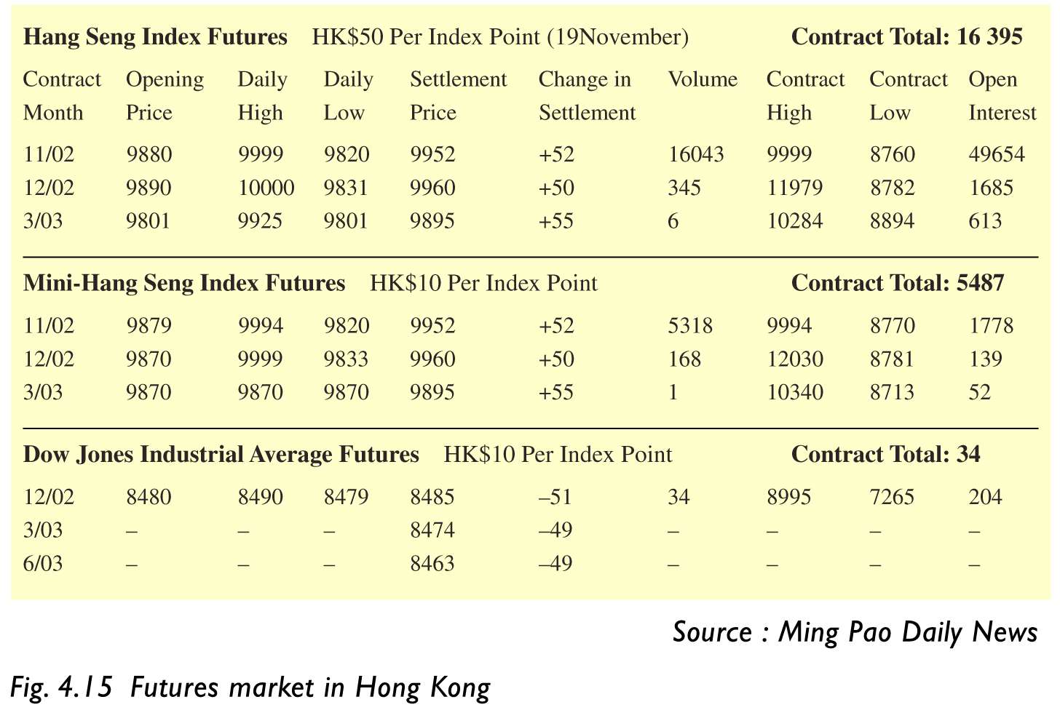
88 | Point C1. line 1 to 2  “…trade routes and at southern China.” |  |  |  |  |  |  |  |  |  | “…trade routes and in the southern part of the mainland.”
 | News Online 4.4,Dr Economics says, line 2:  “more Chinese firms to Hong Kong …” |  |  |  |  |  |  |  |  |  | “more firms from the mainland to Hong Kong …”
89 | Point 7. line 2  “…Hong Kong-Mainland business…” |  |  |  |  |  |  |  |  |  | “…mainland-Hong Kong business…”
92 | The text box at the bottom  “Deposit-taking company” |  |  |  |  |  |  |  |  |  | “Deposit-taking companies”
99 | Point 3, The formula of liquidity ratio:  Short-term liquid assets in a bank x 100%  Short-term liabilities in a bank |  |  |  |  |  |  |  |  |  | Short-term liquid assets x 100%  Short-term liabilities
99 | Point 3, 2nd para., line 1:  “Short-term liabilities are demand deposits…” |  |  |  |  |  |  |  |  |  | “Short-term liabilities include demand deposits…”
99 | Point 3, 2nd para., line 2:  “Short-term assets are” |  |  |  |  |  |  |  |  |  | “Short-term assets include”
99 | Point 3, 4th para., line 1 to line 2:  “Banks in … of 25% each month.” |  |  |  |  |  |  | “All authorized institutions in Hong Kong (licensed banks, restricted licence banks and deposit-taking companies) are required to meet a minimum monthly average liquidity ratio of 25%.”
104 | News Online 5.1., line 2:  “…would lead to a fall in …” |  |  |  |  |  |  |  |  |  | “…would lead to a rise in …”
107 | Section D, point 1, line 2:  “The money may be spent right away.” |  |  |  |  |  |  |  |  |  | Delete this sentence.
118 | Point B, 2nd para., line 2 to line 4:  “…are classified as unemployed if they do not have jobs or enterprises. (If a voluntary worker does not intend to find any other jobs, he is not in the labour force.)” |  |  |  |  |  |  |  |  |  | “…and they do not intend to find any other jobs, they are not in the labour force.)”
118 | Point C, line 1:  “… refers to those labour force who is” |  |  |  |  |  |  |  |  |  | “…refers to those labour force who are”
121 | The bottom of the page:  “Close Look 6.3…HKCEE syllabus.” |  |  |  |  |  |  |  |  |  | “Closer Look 6.3 …HKCEE syllabus.”
128 | Para 3, 1st point, line 3  ．…as food, transport and housing. |  |  |  |  |  |  |  |  |  | ．…such as food.
129 | The text box of the formula:  Implicit Price Deflator of GDP  = GDP at Current Market Prices x 100%  GDP at Current Market Prices |  |  |  |  |  |  |  |  |  | Implicit Price Deflator of GDP  = GDP at Current Market Prices x 100  GDP at Current Market Prices
133 | Point 4, line 3:  “according the change in …” |  |  |  |  |  |  |  |  |  | “according to the change in …”
134 | Point 6 (a), the last line:  “persistently decreased.” |  |  |  |  |  |  |  |  |  | “persistently decreases.”
134 | Point 6 (b), line 2 to 4  “money (or …) … persistently increased.” |  |  |  |  |  |  |  |  |  | “(or …) … persistently increases.”
135, 136, 137, 139, 141, 259 |  |  |  |  |  | “GNP” |  |  |  |  | “GDP”
139 | Economics Clinic, Q 3, Option C:  C. The national GNP growth rate increases by 8%. |  |  |  |  |  |  |  |  |  | C. The real GDP growth rate increases by 8%.
141 | Multiple-choice Questions, Q 3. , Options A ＆ B  A. A full-time Form Five student  B. A voluntary worker in YMCA  . |  |  |  |  |  |  |  |  |  | A. A 14-year-old schoolboy  B. A retired person who does voluntary work in YMCA
142 | Structured Questions, Q 1(d)  (d) Find the money GDP in 2003. (1 mark) |  |  |  |  |  |  |  |  |  | Delete this part.
143 | New Fig. 7.1 How doe the government make use of public expenditure and government revenue to achieve economic goods?  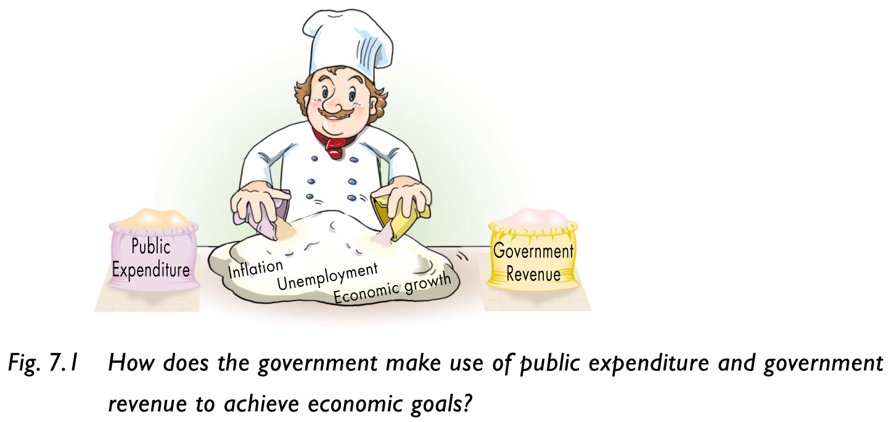
153 | The note on the margin, point 3:  3. Heavy progressive tax: higher income …will work more.” |  |  |  |  |  |  |  |  |  | 3. Taxes with higher progressivity will lower working incentives.
154 | News Online 7.1, Dr Economics says, the last line:  “Dining outside is a luxury good …” |  |  |  |  |  |  |  |  |  | “Dining out is a luxury good …”
158 | Closer Look 7.3, 1st para., line 1:  “An increase in gasoline tax will …” |  |  |  |  |  |  |  |  |  | “An increase in gasoline tax³¹ will …”
158 | Closer Look 7.3, 3rd para.3:  “An increase in … cars using tunnels.” |  |  |  |  |  |  |  |  |  | Delete this para.
158 | Footnote no. 31  tunnel toll 隧道行車費 |  |  |  |  |  |  |  |  |  | Footnote no. 31  gasoline tax 汽油稅
159 | New Fig. 7.14 Can you think of other pros and cons of imposing sales tax?  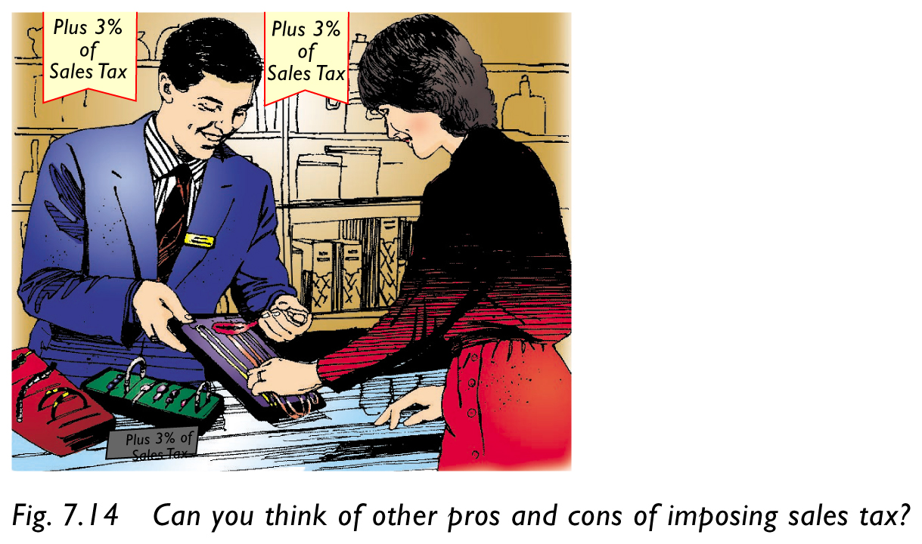
159 | Table 7.11, “Pros”, 1st point, line 1 to line 2:  ．…tax base, government revenue … |  |  |  |  |  |  |  |  |  | ．…tax base. Government revenue…
160 | Column of “ Main Items”, row 3 “ Social Welfare”  “Social welfare, rehabitation services, elderly…” |  |  |  |  |  |  |  |  |  | “Social welfare, rehabilitation services, elderly…”
164 | Point D, the text box of formula:  Public Expenditure as a Proportion of GDP  = Public Sector Expenditure x 100%  GDP |  |  |  |  |  |  |  |  |  | Delete “Sector”.
170 | Economics Clinic, Q 3, Option (b)  The Y-axis “Taxable Income” and the X-axis “Tax Payment” is to be exchanged. |  |  |  |  |  |  |  |  |  | The Y-axis: “Tax Payment” and  the X-axis: “Taxable Income”
175 | Objectives, point (2):  (2) understand the law of … |  |  |  |  |  |  |  |  |  | Objectives  (2) understand the laws of …
175 | Fig. 8.1 International trade  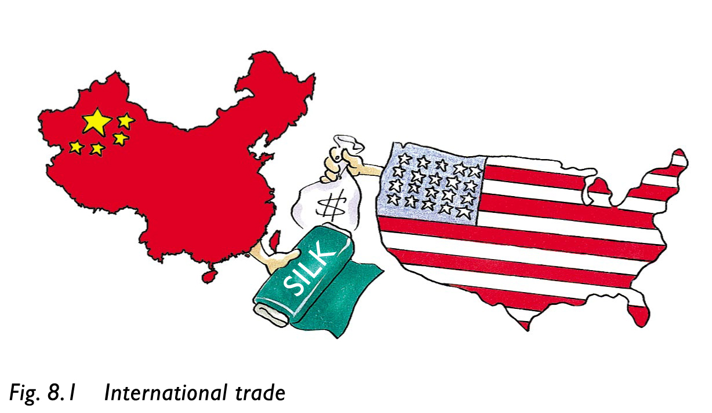  (the map of China has been revised)
182, 191, 192, 257 |  |  | “China” |  |  |  |  |  | “The mainland of China” or “the mainland of China”
182 | Point “China:” 3rd para., line 1:  “China will trade …” |  |  |  |  |  |  |  |  |  | “She will trade…”
188 | Economics Clinic, Q 1, Dr Economics says, Line 2  “… depends on the following.” |  |  |  |  |  |  |  |  |  | “… depends on two other conditions.”
188 | Economics Clinic, Q 1, Dr Economics says, (1)-(3)  (1) The opportunity costs …concerned .  (2) A mutually beneficial … .  (3) There are gains from trade … . |  |  |  |  |  |  |  |  |  | Option (1) is deleted. .  (1) A mutually beneficial … .  (2) There are gains from trade … .
197 | News Online 9.1  China and Free Trade |  |  |  |  |  |  |  |  |  | News Online 9.1  The Mainland of China and Free Trade
197 | News Online 9.1, line 1  “The Mainland…arrangements." |  |  |  |  |  |  |  |  |  | Delete this sentence.
197 | News Online 9.1, Dr Economics says, line 3 & line 4:  “Western regions” |  |  |  |  |  |  |  |  |  | “western regions”
197, 199, 201 |  | “China” |  |  |  |  |  |  |  |  | “the mainland” or “The mainland”
197, 199, 201 |  | “China’s” |  |  |  |  |  |  |  |  | “the mainland’s” or “The mainland’s”
199 | News Online 9.2  China On Her Way To WTO |  |  |  |  |  |  |  |  |  | News Online 9.2  The Mainland of China On Her Way To WTO
199 | News Online 9.2, line 2  “U.S.A.” |  |  |  |  |  |  |  |  |  | “the U.S.A.”
199 | News Online 9.2, Dr Economics says, point 2, line 1:  “the Mainland.” |  |  |  |  |  |  |  |  |  | “the mainland”
201 | News Online 9.3 China…Steel |  |  |  |  |  |  |  |  |  | News Online 9.3 The Mainland of China…Steel
202, 203 | “China” |  |  |  |  |  |  |  |  |  | “the mainland of China”
203 | News Online 9.4, line 1 to line 2:  “…Mainland China…in the Mainland …” |  |  |  |  |  |  |  |  |  | “…the mainland of China…in the mainland …”
210 | Multiple-choice Questions, Q 3 Options A & C  A. China  C. the U.S. A. |  |  |  |  |  |  |  |  |  | A. The mainland of China  C. The U.S.A.
211 | Question 4 : “China”; “the Mainland” |  |  |  |  |  |  |  |  |  | “The mainland of China”; “the mainland”
217 | Q10.3 (c) , line 2: “China” |  |  |  |  |  |  |  |  |  | “the mainland”
217 | Point C, 2nd para., line 2:  “Certificates of Indebtedness” |  |  |  |  |  |  |  |  |  | (Note: the whole “Point C” is put to p. 218)  “Certificates of Indebtedness¹²”
218 | 1st para., line 2 :“linked rate” |  |  |  |  |  |  |  |  |  | “linked rate¹³”
218 | 2nd para. is revised. |  |  |  | “Licensed banks in Hong Kong have clearing accounts with the Hong Kong Monetary Authority for the purpose of clearing and settling transactions between the banks themselves and also between the banks and the Hong Kong Monetary Authority. The Hong Kong Monetary Authority undertakes to convert Hong Kong dollars in the clearing accounts into US dollars at the linked rate.”
218 | Footnote no. 12:  arbitrage 套戥 |  |  |  |  |  |  |  |  |  | Footnote no. 12:  Certificates of Indebtedness 負債証明書
218 | Footnote no. 13 : transaction cost 交易成本 |  |  |  |  |  |  |  |  |  | linked rate 聯繫匯率
218-219 | Closer Look 10. 2 is deleted.
220 | Fig. 10.7 Japanese…yen appreciates |  |  |  |  |  |  |  |  |  | Fig. 10.5 Japanese…yen appreciates (put to p.219)
220 | New Fig. 10. 6 (a) and (b) are added and inserted between point 2 (a) and point 2 (b)  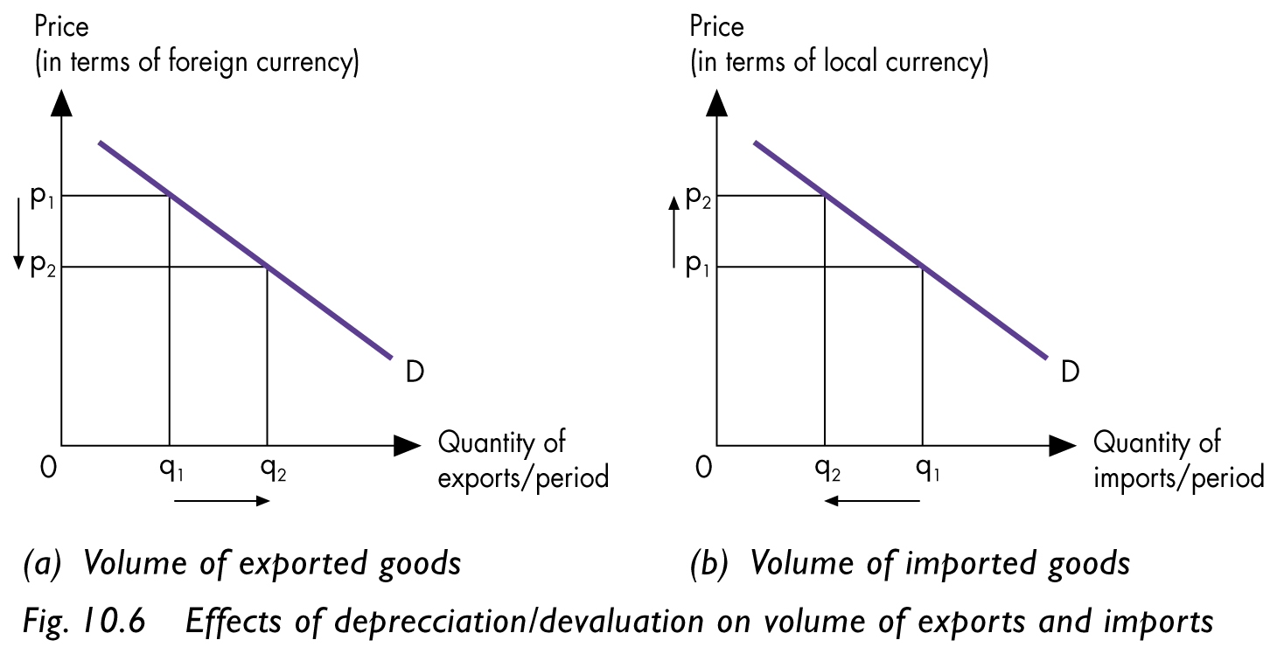
220 | Fig. 10. 7 (a) and (b) are added and inserted between point (b) and Q 10.4  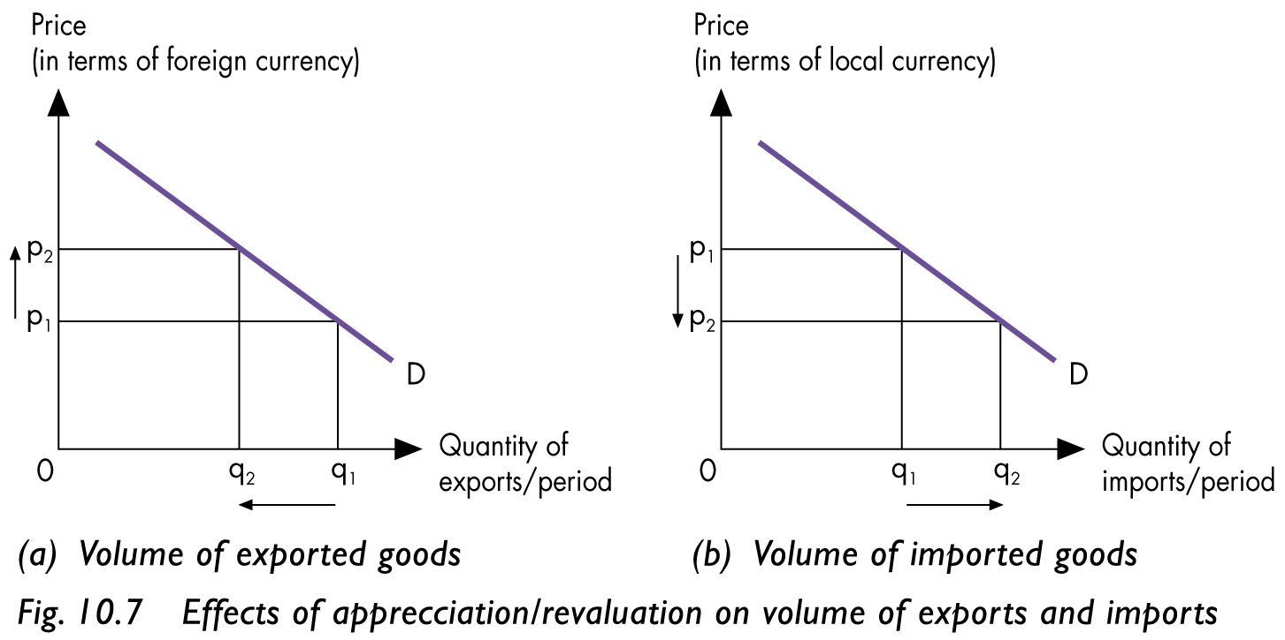
222 | Footnote no. 19  balance of trade 貿易平衡 / 貿易差額 |  |  |  |  |  |  |  |  |  | Delete “貿易平衡”.
223 | News Online 10.3, Dr Economics says, 1ine 1:  “…in the invisible trade component …” |  |  |  |  |  |  |  |  |  | “…in the services component …”
224 | Point 3, 1st para.:  “…the income ²¹ by … and the income earned by …is known as net income from abroad ²².” |  |  |  |  |  |  |  |  |  | “…the factor incomes ²¹ by … and the factor incomes earned by …is known as net factor income from abroad ²².”
224 | Point 3, Examples:  “Profits …bank deposits.” |  |  |  |  |  |  |  |  |  | “Earnings of residents from investment in non-resident stocks and shares.”
224 | The note on the margin  “Net Income from Abroad: = Income earned by…- Income earned by …Economy.” |  |  |  |  |  |  |  |  |  | “Net Factor Income from Abroad: = Factor Incomes earned…- Factor Incomes earned by …Economy”
224 | Footnote no. 21  income 收入/收益 |  |  |  |  |  |  |  |  |  | Footnote no. 21  factor incomes 要素收入/要素收益
224 | Footnote no. 22  net income from abroad  來自外地的收益淨值 |  |  |  |  |  |  |  |  |  | Footnote no. 22  net factor income from abroad  外地生產要素所得淨值
226 | Closer Look 10.3 ＝＞ Closer Look 10.2
227 | Closer Look 10.4 ＝＞ Closer Look 10.3
228 | Closer Look 10.5 ＝＞ Closer Look 10.4
229 | Closer Look 10.6 ＝＞ Closer Look 10.5
231 | Point 2, 2nd para.: “In 2001, Hong Kong …billion.” |  |  |  |  |  |  |  |  |  | “In 2001, Hong Kong’s invisible trade surplus was $115 204 million (as updated on 27th May 2004).”
231 | Point 3, line 3 to line 4:  “In 2001, Hong Kong … billion.” |  |  |  |  |  |  |  |  |  | “ In 2001, Hong Kong’s current account surplus was $531 million (as updated on 27th May 2004).”
232, 235, 236, 238, 239 |  |  |  | “China” |  |  |  |  |  |  | “the mainland”
236 | Economics Clinic,Dr Economics says,option D, line 2  D. …more US-China trade |  |  |  |  |  |  |  |  |  | D. …more mainland-US trade.
238 | Multiple-choice Questions Q 5  5. Which of the following will improve Hong Kong’s current account? |  |  |  |  |  |  |  |  |  | 5. Which of the following will improve Hong Kong’s current account balance?
239 | Structured Questions, Q 2 (a), line 2:  (a) …how would Hong Kong’s exports and employment be affected? Explain your answer. |  |  |  |  |  |  |  |  |  | (a) …how would Hong Kong’s export prices be affected? Explain your answer.
242 | Fig. 11.2  The nametag of the television :“China” |  |  |  |  |  |  |  |  |  | “The mainland of China”
244, 245, 254 |  |  | “the Mainland”/ “China” |  |  |  |  |  |  |  | “the mainland”
244 | “China’s” ＝＞ “The mainland’s” / “The Mainland’s”  “Western region” ＝＞ “western region”
Closer Look 11.1 point B, 3rd point is revised as follows:
．The mainland’s entry to WTO and her opening up of the western region created great demand for funds and financial services. Hong Kong has great opportunities to do the funding.
247 | Table 11.2  The national flags under the column of Major Suppliers are replaced by the names of the respective regions/countries |  |  |  |  |  |  |  |  |  | The mainland of China  Japan  Taiwan
248 | Table 11.4  The national flags under the column of Major Markets are replaced by the names of the respective regions/countries. |  |  |  |  |  |  |  |  |  | The mainland of China  The U.S.A  The U.K.
248 | Fig. 11.7  “China”  “U.S.A.”  “U.K.” |  |  |  |  |  |  |  |  |  | Fig. 11.7  “The mainland of China”  “The U. S. A.”  “The U.K.”
248 | Fig. 11.8  The national flags under the column of Major Origins are replaced by the names of the respective regions/countries. |  |  |  |  |  |  |  |  |  | (1) The mainland of China  (2) Japan  (3) Taiwan
248 | Fig. 11.8  The national flags under the column of Major Re-export Markets are replaced by the names of the respective regions / countries. |  |  |  |  |  |  |  |  |  | (1) The mainland of China  (2) The U.S.A.  (3) Japan
249, 250 | “U.S.A.” ＝＞ “The U.S.A.”  “Mainland of China” ＝＞ “The mainland of China”
251, 260 | “China” |  |  |  |  |  |  |  |  |  | “the mainland”
251, 260 | “…Chinese exports have …” |  |  |  |  |  |  |  |  |  | “…exports from the mainland have …”
251 | In Fig. 11.11, “China” ＝＞ “The mainland of China”
252 | Point 2, line 2 to line 3:  “…China and the U.S.A. buy over … Clothing and textiles account for …” |  |  |  |  |  |  |  |  |  | “…the mainland of China and the U.S.A. bought over Clothing and textiles accounted for …”
257 | Structured Questions Q 1 (a), line 1  “Hong Kong is a manufacturing centre.” |  |  |  |  |  |  |  |  |  | Delete this sentence.
258 | Column 1, answers to Chapter 2,  “2.1 No, …services.” => “2.3 No, …services.”  “2.2 (a) …(b)…(c)…” => “2.1 (a)…(b)…(c)…”  “2.3 Value added…$30.” => “2.2 Value added…$30.” (due to the change of the layout of Chapter 2)
258 | 2.6 “GNP” => “GDP”
261 | Column 1, answers to HKCEE Questions -- Chapter 2  4. A => 4. B  5. B => 5. A (due to the change of the layout of chapter 2)
264 | Glossary - Chapter 4  clearing house (票據交換所), line 1 and line 2:  “…where cheques and cleared …” |  |  |  |  |  |  |  |  |  | “…where cheques are cleared … “
266 | Glossary, Column 1- Chapter 7:  Public Expenditure as a Proportion of GDP  = Public Sector Expenditure x 100%  GDP |  |  |  |  |  |  |  |  |  | Delete “Sector”.
267 | Glossary – Chapter 10, column 2:  balance of trade (貿易平衡 / 貿易差額) |  |  |  |  |  |  |  |  |  | Delete “貿易平衡 ”
268 | Index, column 1, “A”, line 6: arbitrage 218 |  |  |  |  |  |  |  |  |  | This item is deleted.
268 | Index column 1, “C”, 3rd last line:  Certificate of Indebtedness 60 |  |  |  |  |  |  |  |  |  | Certificate of Indebtedness 60, 218
269 | Column 2, “L”, 8th line: Linked Exchange Rate System 217 ＝＞ Linked Exchange Rate System 218
269 | Column 2, “L”, insert “linked rate 218” following “Linked Exchange Rate System 217”
269 | Column 2, “N”, 4th and 3rd last lines  net factor income from abroad 26 ＝＞net factor income from abroad 26, 224  net income from abroad 224 ＝＞ This item is deleted
269 | Column 3, “P”, 4th last line: prosperity 135 |  |  |  |  |  |  |  |  |  | prosperity 136
270 | Column 1, “T”, 4th last line: transaction cost 218 |  |  |  |  |  |  |  |  |  | This item is deleted.

